Images of our 2021 September Visit at Bear Spring Camps, Belgrade Lakes, Maine

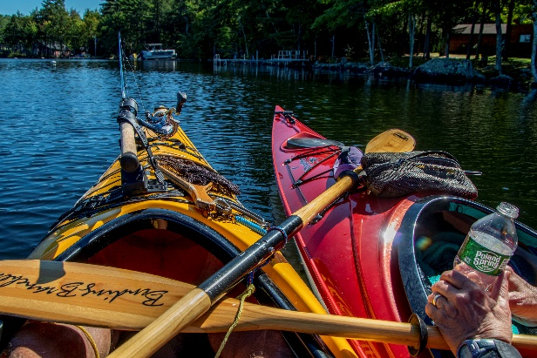September arrived and we motored over to the Bear Spring Camps in Belgrade, Maine, after stopping at L. L. Beans in Freeport, of course. This annual holiday brought excellent kayaking on calm waters with several interesting wind/rain/lightning activities to keep Maine honest. The C19 panademic had eased and we thoroughly enjoyed the fresh fruit at breakfast and the delicious variety of evening entrees. This album includes various photos of us kayaking around Great Pond, focusing on the Great Meadow Stream and doing this and that while absorbing the wildlife and tranquility.

The leasure atmosphere and outdoor opportunities were excellent as usual and we are looking forward to returning to Bear next year.

And for the photos, click [Bear Spring Camps, ME, - September 2021.](https://photos.app.goo.gl/SXcW3QggKEAizUY37) You are encouraged to “zoom in”.